Nguyen Thanh Binh_25062677_AFDM_A1

Financial Analysis Report

Student Number: 25062677 - 10240511

1.1 Company Information
Founded in 2005 as an extension of the University of Oxford, Oxford Nanopore Technologies PLC (ONT) is a UK-based company operating in the Biotechnology and Life Sciences sector, offering advanced methods ranging from single-molecule to nanopore-based sequencing technology (NanoporeTech, 2026). The company is famous for the development of DNA/RNA sequencing technology, a technology that offers fast analysis and explains complex biological information in the present time, and is being used by more than 100 countries worldwide (Oxford Nanopore Technologies, 2025b). In 2024, ONT recorded approximately £183 million in revenue, achieving an impressive 23% underlying constant currency growth (IP Group PLC, 2025). With the business expansion beyond academic research into applied markets, which include clinical diagnostics and biomanufacturing, the firm has acquired a £50 million equity investment from Novo Holdings (Novo Holdings, 2024).

1.2 Sector Analysis
The Biotechnology and Life Sciences sector plays a crucial economic pillar in the UK. In 2024, the sector generated approximately £146.9 billion in turnover while employing nearly 359,000 professionals across 6,170 businesses. (GOV.UK, 2025). According to Amoroso (2026), the main driver of this growth is technological megatrends, with pharmaceutical Research and Development (R&D) sustaining its relative strength and achieving £9 billion at the beginning of 2024. Despite macroeconomic pressures such as rising interest rates, the sector saw robust demand. Equity financing secured £3.7 billion, a 106% increase from the previous year, together with £2.25 billion in venture capital (VC), making 2024 the strongest year for VC funding and displaying the flexibility of the sector (Bates, 2025). Overall, having this much funding and the flexibility keeps the industry safe and protected even when the macroeconomy is struggling, making the sector a great place for long-term investment.

2 Financial Report

2.1 Core financial ratios
The financial structure and performance of ONT can be evaluated over the period from 2022 to 2024.

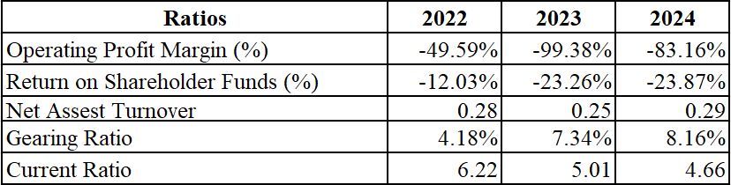
Table 1: Key ratios of Oxford Nanopore Technologies
ONT is currently in a “spend money to grow” phase, which is a normal and typical scheme for new biotech companies. The firm’s Operating Profit Margin (OPM) declined significantly from -49.59% in 2022 to -99.38% in 2023, then recovered to -83.16% by the end of the period. These losses are not a mistake; however, they are part of a planned business strategy. The reason for this is their heavy spending on business facilities, the launch of their PromethION 2 system, and a planned move away from highly profitable COVID-19 testing revenues (Sanghera, 2024). Because of this, the Return on Shareholder Funds (ROSF) stayed very negative, dropping from -12.03% in 2022 to -23.87% in 2024.
The Gearing Ratio stayed very low during this period, at 3.85% in 2022, 6.40% in 2023, and 7.01% in 2024. This shows that the company relies almost entirely on its own equity rather than debt, which gives it a lot of available cash. ONT concluded 2024 with a net cash position of approximately £302 million, ensuring sufficient short-term liquidity to sustain its research and development without the stress of paying high interest on loans (Alliance News, 2026).
Net Asset Turnover (NAT) for ONT changed slightly between 0.28 in 2022 and 0.29 in 2024. A NAT below 1.0 is characteristic of companies that need a lot of money to run (Allianz Trade, 2026). Since the firm often holds large amounts of cash and valuable technology that do not turn into sales right away, the small improvement at the end of the period shows early signs that the business is becoming more efficient as its new products start to sell better.
The firm's current ratio shows a declining liquidity position over the three-year period, falling from 6.22 in 2022 to 4.66 in 2024. Although these figures remain well above the generally accepted benchmark, they are largely driven by cash raised through selling shares rather than income from operations. As of December 2024, ONT held £403.8 million in cash, cash equivalents, and other liquid investments, compared to £472.1 million in 2023, indicating that its reserves are gradually being used up (IP Group PLC, 2025). While the ratio still appears strong on the surface, the steady decline is a warning sign that the company spends its cash faster than it generates from business operations.

2.2 Financial performance comparison to sector.
To better understand ONT's financial situation, it is useful to compare it with Genus PLC, an older UK biotechnology company that focuses on animal genetics.
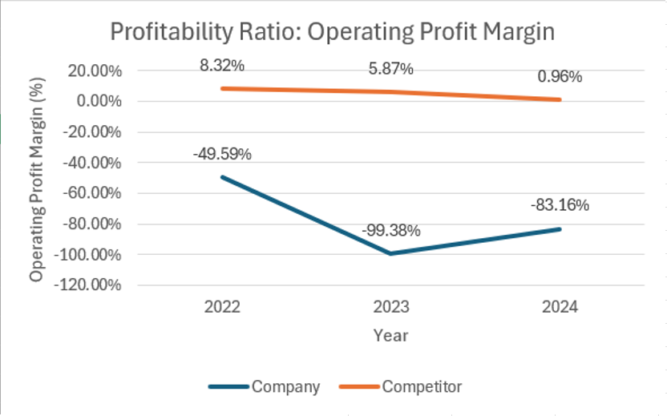
Figure 1: Operating Profit Margin between ONT and GNS.
ONT has recorded deeply negative operating profit margins throughout the period, falling as low as -99.38% in 2023 before partially recovering to -83.16% in 2024. In 2023, the firm’s net loss reached £154.5 million, largely driven by a 50% increase in R&D spending to £103.8 million (IP Group PLC). Genus PLC, while consistently profitable, has seen its margin shrink significantly from 8.32% in 2022 to just 0.96% in 2024. Genus reported lower adjusted operating profit in its most recent period, reflecting challenging market conditions across several regions (Genus PLC, 2023).
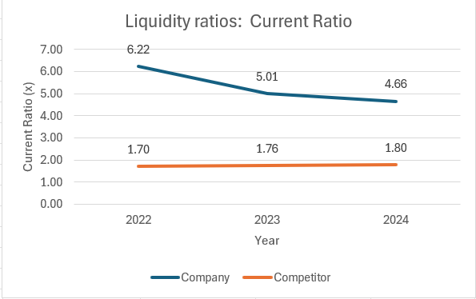
Figure 2: Current Ratio between ONT and GNS.

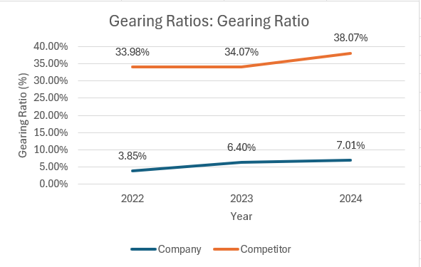
Figure 3: Gearting Ratio between ONT and GNS.
Unlike ONT, the structural risks linked to Genus's maturity differ in nature. Genus relies significantly more on debt financing, indicated by a Gearing Ratio of 38.07%, whereas ONT maintains a very low 7.01%. Additionally, while ONT burns through cash rapidly, it protects itself against insolvency with a much higher Current Ratio of 4.66, compared to Genus's standard 1.80.
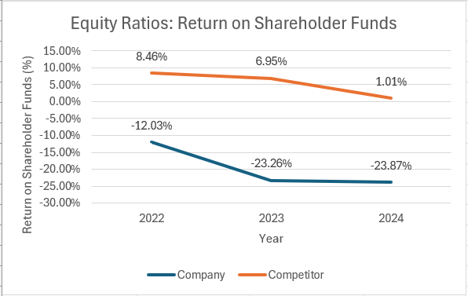
Figure 4: Return on Shareholder Funds between ONT and GNS.
ONT's ROSF has remained deeply negative, worsening from -12.03% in 2022 to -23.87% in 2024, reflecting continuous net losses. ONT recorded an operating loss of £152.3 million in 2024 and £168.6 million in 2023, confirming that the company is still far from profitable (Oxford Nanopore Technologies, 2025a). Genus PLC, while remaining in positive territory, has seen its ROSF fall sharply from 8.46% in 2022 to just 1.01% in 2024. For the full year ended June 2024, Genus reported net income of only £7.9 million, a significant drop from £33.3 million in the prior year, which directly explains its declining shareholder returns (Genus PLC, 2024).

3 Market Report

3.1 Core Market Coefficients and ratios
An analysis of market coefficients measures how ONT shares on the London Stock Exchange have performed in the past, as well as their likely future returns and levels of risk.
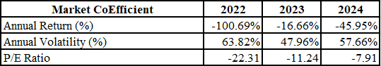
Table 2: Key Market Coefficients and Performance Metrics for ONT Shares.
ONT faced a significant decrease in market value during this period, recording substantial negative annual returns of -100.69% in 2022 and -45.95% in 2024. This sharp decline in price was largely due to a general shift in the economy away from unprofitable growth stocks, a change triggered by increasing interest rates from central banks (IP Group PLC, 2024). The stock also exhibits extreme volatility, peaking at 63.82% in 2022 and remaining elevated at 57.66% in 2024.
Regarding its risk profile, ONT has a 3-year Beta of 1.40, which suggests the stock is 40% more volatile than the wider market. As a "high-beta" asset, ONT is particularly sensitive to changes in general market confidence. Additionally, the Price-to-Earnings (P/E) ratio remained in negative territory, moving from -22.31 in 2022 to -7.91 in 2024. Since a negative P/E ratio is the result of a company failing to generate profit, the fact that this figure is moving closer to zero indicates a rapid fall in the stock price rather than any actual growth in earnings (Alliance News, 2025).

3.2 Market performance comparison to sector
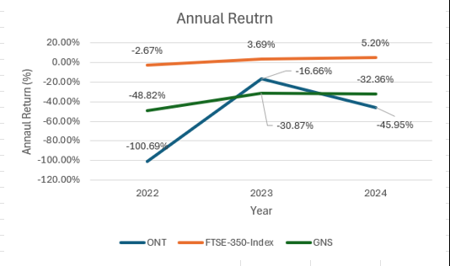
Figure 5: Comparative Annual Returns Trend: ONT, GNS, and FTSE-350.

Figure 6: Comparative Annual Volatility Trend: ONT, GNS, and FTSE-350.
Between 2022 and 2024, both ONT and GNS experienced significant financial instability and poor outcomes when compared to the broader market benchmark, the FTSE-350 Index. Specifically, ONT recorded the most dramatic fluctuations and worst performance, with annual losses plummeting to -100.69% in 2022, supported by extreme volatility ranging between 63.82% in 2022 and 57.66% in 2024. Similarly, GNS demonstrated a continuous level of instability, maintaining consistently negative returns that fluctuated between –48.82% and -32.36% over the period.

4 Conclusion

4.1 Conclusion and Recommendation
An analysis of Oxford Nanopore Technologies PLC (ONT) shows that the company is currently experiencing what is known as a "J-curve" growth pattern (Kenton, 2025). From a financial perspective, the company is not making a profit, with its operating margins falling to -83.16% in 2024. However, this lack of profitability is an expected consequence of its rapid business expansion. Despite these short-term financial losses, the core business remains highly resilient, as demonstrated by a 23% increase in revenue in 2024, alongside growing success in both medical and industrial markets (Oxford Nanopore Technologies, 2025a). Most importantly, ONT has very low debt levels and is strongly supported by Novo Holdings (Novo Holdings, 2024). This strong financial foundation protects the company from the severe debt problems currently affecting competitors, such as Genus PLC.
For an investor who can accept a higher level of risk and has a long-term strategy, ONT would be an attractive investment. Its excellent financial health ensures the company will continue to operate, while its growing sales and strategy suggest the stock’s value is likely to increase significantly once broader economic conditions improve.

5 Appendix
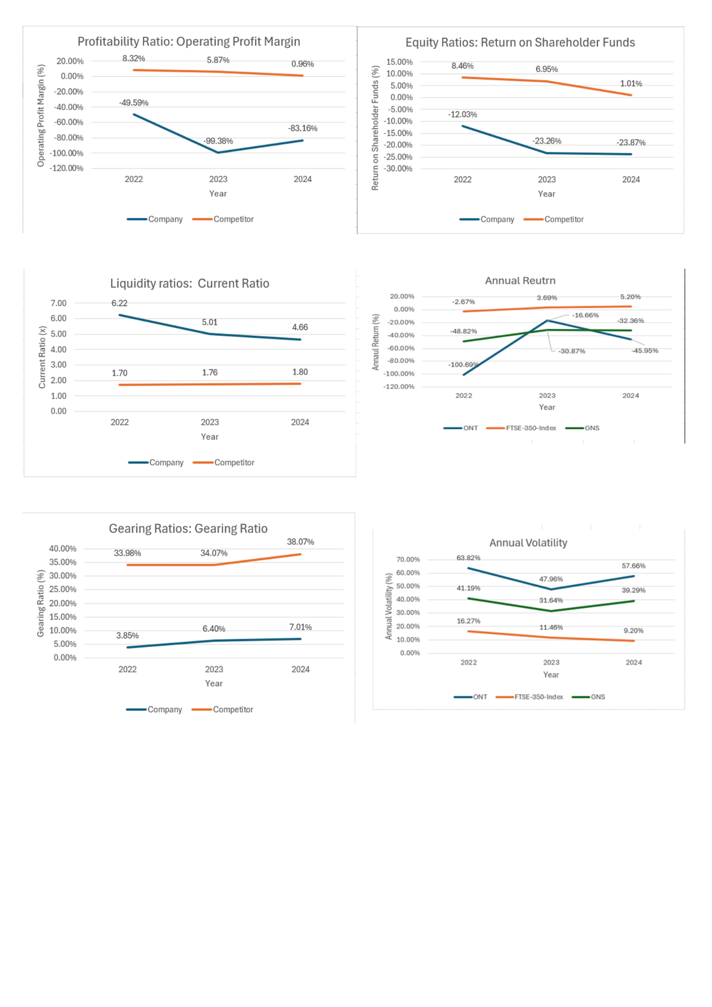

Declaration of using Generative AI.
Generative artificial intelligence (GenAI) was used in the work. I, the author, have reviewed and edited the content as needed and take full responsibility for the content, claims, and references. An overview of the use of GenAI is provided below:
- I used Grammarly to check for all grammatical and vocabulary errors, mistakes that occurred during the time I wrote the report. The AI automatically fixes errors/mistakes that happened during my work. The final submission is reviewed and checked by the AI.
- I used Gemini to help me plan the structure of the report. The way that I use Gemini is strictly for reference. I requested the AI to generate a template to better understand the methodology and structural requirements of this report. I did not replicate the AI's output, as its content differs significantly from my work; rather, I used it solely as a guide for formatting and approach. Here is an example of my prompt to the AI: “Using the given files, generate for me an overview of the given assignment. The outcomes should be covered in a clear way for me to understand the assignment and the way I should be presented in my report.”

6 References

Alliance News. (2025). Oxford Nanopore closer to profitability after revenue growth in 2024 | AJ Bell. Available at: https://www.ajbell.co.uk/news/articles/oxford-nanopore-closer-profitability-after-revenue-growth-2024 (Accessed: 5 March 2026).
Alliance News. (2026). Oxford Nanopore says full year revenue will be slightly ahead of hopes, Morningstar, Inc. Available at: https://global.morningstar.com/en-gb/news/alliance-news/1768210179609811900/oxford-nanopore-says-full-year-revenue-will-be-slightly-ahead-of-hopes (Accessed: 4 March 2026).
Allianz Trade. (2026). Asset Turnover Ratio: Definition, Formula And Practical Insights, Allianz Trade Corporate. Available at: https://www.allianz-trade.com/en_US/insights/asset-turnover-ratio.html (Accessed: 5 March 2026).
Amoroso, G. (2026). UK R&amp;D Spending Surges in 2025, Led by Pharma and Biotech, FI Group UK. Available at: https://www.fi-group.uk/uk-rd-spending-surges-in-2025-led-by-pharma-and-biotech/ (Accessed: 1 March 2026).
Bates, S. (2025). ‘Finance Report 2024 – Biotech Finance’, 27 January. Available at: https://biotechfinance.org/finance-report-2024/ (Accessed: 1 March 2026).
Genus PLC. (2023). Genus plc Preliminary Results for the Year Ended 30 June 2023. Available at: https://www.businesswire.com/news/home/20230906828945/en/Genus-plc-Preliminary-Results-for-the-Year-Ended-30-June-2023 (Accessed: 4 March 2026).
Genus PLC. (2024). Genus plc Preliminary Results for the Year Ended 30 June 2024. Available at: https://www.businesswire.com/news/home/20240904874140/en/Genus-plc-Preliminary-Results-for-the-Year-Ended-30-June-2024 (Accessed: 4 March 2026).
GOV.UK. (2025). Bioscience and health technology sector statistics 2023 to 2024, GOV.UK. Available at: https://www.gov.uk/government/statistics/bioscience-and-health-technology-sector-statistics-2023-to-2024/bioscience-and-health-technology-sector-statistics-2023-to-2024 (Accessed: 1 March 2026).
IP Group PLC. (2024). Oxford Nanopore Technologies plc - FY23 trading update. Available at: https://www.ipgroupplc.com/news-and-events/portfolio-news/2024/2024-01-09 (Accessed: 5 March 2026).
IP Group PLC. (2025). Oxford Nanopore Technologies plc - Full Year Trading Update and Notice of Results. Available at: https://www.ipgroupplc.com/news-and-events/portfolio-news/2025/2025-01-13 (Accessed: 28 February 2026).
Kenton, W. (2025). J Curve: Definition and Uses in Economics and Private Equity, Investopedia. Available at: https://www.investopedia.com/terms/j/j-curve-effect.asp (Accessed: 5 March 2026).
NanoporeTech. (2026). About Us. Available at: https://nanoporetech.com/about (Accessed: 28 February 2026).
Novo Holdings. (2024). Novo Holdings Invests in UK-Listed Oxford Nanopore Technologies. Available at: https://www.prnewswire.com/news-releases/novo-holdings-invests-in-uk-listed-oxford-nanopore-technologies-302211684.html (Accessed: 28 February 2026).
Oxford Nanopore Technologies. (2025a). News article. Available at: https://www.londonstockexchange.com/news-article/ONT/annual-results-for-the-year-ended-31-december-2024/about:blank (Accessed: 4 March 2026).
Oxford Nanopore Technologies. (2025b). Oxford Nanopore Technologies LinkedIn. Available at: https://www.linkedin.com/company/oxford-nanopore-technologies (Accessed: 28 February 2026).
Sanghera, G. (2024). Preliminary results for the year ended 31 December 2023, Oxford Nanopore Technologies. Available at: https://nanoporetech.com/news/news-preliminary-results-year-ended-31-december-2023 (Accessed: 3 March 2026).

